Snap-Shot of servers-

[Net.ServicePointManager]::SecurityProtocol = [Net.SecurityProtocolType]::Tls12

Login-AzureRmAccount

Set-AzureRmContext -SubscriptionName "NITL-BRIT"

$resourceGroup = "BRIT-MGMT-RG"

$Location = "North Europe"

$destrg = "BRIT-PATCH-SNAPSHOT"

$Vms = Get-AzureRMVM -ResourceGroupName $resourceGroup

foreach ($VM in $Vms)

{

$OsDiskName = (Get-AzureRMVM -Name $VM.Name -ResourceGroupName $ResourceGroup).StorageProfile.OSDisk.Name

$OsDiskId = (Get-AzureRMDisk -Name $OsDiskName -ResourceGroupName $ResourceGroup).Id

$OsDiskSnapshotConfig = New-AzureRMSnapshotConfig -SourceUri $OsDiskId -Location $Location -CreateOption "Copy" -SkuName Standard_LRS

$SnapshotName = $((Get-Date -Format s).Replace(":", "-") + "-" + $VM.Name + "-Snapshot-" + "OsDisk" + "-Patching")

If ($SnapshotName.Length -ge 79)

{

$SnapshotName = $SnapshotName.Substring(0, 79)

}

New-AzureRMSnapshot -Snapshot $OsDiskSnapshotConfig -SnapshotName $SnapshotName -ResourceGroupName $destrg

$DataDisks = (Get-AzureRMVM -Name $VM.Name -ResourceGroupName $ResourceGroup).StorageProfile.DataDisks.Name

foreach ($DataDisk in $DataDisks)

{

$DataDiskID = (Get-AzureRMDisk -Name $DataDisk -ResourceGroupName $ResourceGroup).Id

$DataDiskSnapshotConfig = New-AzureRMSnapshotConfig -SourceUri $DataDiskID -Location $Location -CreateOption "Copy" -SkuName Standard_LRS

$SnapshotName = $((Get-Date -Format s).Replace(":", "-") + "-" + $VM.Name + "-Snapshot-" + $DataDisk+ "-Patching")

If ($SnapshotName.Length -ge 79)

{

$SnapshotName = $SnapshotName.Substring(0, 79)

}

New-AzureRMSnapshot -Snapshot $DataDiskSnapshotConfig -SnapshotName $SnapshotName -ResourceGroupName $destrg -AsJob

}

}

VM Scale-set Script-

[Net.ServicePointManager]::SecurityProtocol = [Net.SecurityProtocolType]::Tls12

Connect-AzAccount

Get-AzSubscription

Set-AzContext -SubscriptionName "NITL-ASCOT"

$rgname = "ASCOT-NEU-PROD-RG"

$vmssname = "ASCPRDUWAppSS"

$Id = 1

$location = "North Europe"

$vmss1 = Get-AzVmssVM -ResourceGroupName $rgname -VMScaleSetName $vmssname -InstanceId $Id

$snapshotconfig = New-AzSnapshotConfig -Location $location -AccountType Standard_LRS -OsType Windows -CreateOption Copy -SourceUri $vmss1.StorageProfile.OsDisk.ManagedDisk.id

New-AzSnapshot -ResourceGroupName $rgname -SnapshotName 'ascprduwa000001-VMSS-Snapshot-_25062023_Patching' -Snapshot $snapshotconfig

Disable/Enable internet on servers-

RegEdit>HkeyLocalMachine>Software>Policy>Microsoft>Windows>WindowUpdate>AU

Closing CH’s of Patching.

* CR has been approved. --- (Authorized)
* Paste content of First Mail Before patching . ---(Implement, Attach mail) – Assign to yourself.
* Snapshots taken successfully. -----(Implement)
* Servers are in maintenance mode. ---(Implement)
* Patches are pushed from the WSUS servers.
* Patches are installed on the servers and takes the servers reboot.
* Patches are installed successfully on the servers and post services are verified. ------(Post Implement)
* Patching has been completed successfully on servers as per the schedule. -------- (Review)
* Informed to the Owner for checking the application/services status and revert back in case of any concern. ----–(Attached Mail) (Closing)
* We are close this CR.

Adding certificates in VM

Window button > Mmc >

Script For CMD(as admin) after certificate install-

wmic /namespace:\\root\CIMV2\TerminalServices PATH Win32_TSGeneralSetting Set SSLCertificateSHA1Hash="3961d7d7ffff19cea74f69952fc848a31662bfe3"

Schedule suspend form:

<https://forms.office.com/r/cbT5QNnz1H>

Servers Sequence to start-

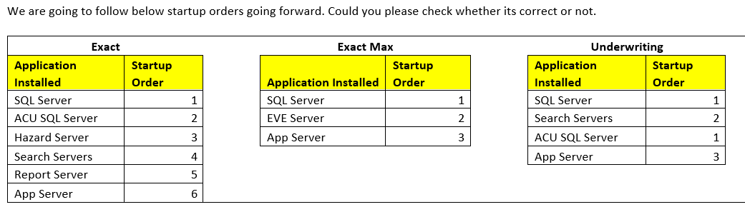

Sequence of services of AXA –

1. Navigator.AXAPROD.SystemNotificationService

2. Navigator.AXAPROD.CacheService

3. Navigator.AXAPROD.BatchService

4. Navigator.AXAPROD.WorkflowManagerService

5. Navigator.AXAPROD.ScheduleWorkflowManagerService

( Navigator.AXAPROD.WorkflowManagerService automatically start with Navigator.AXAPROD.ScheduleWorkflowManagerService)

--------------------------------------------------------------------------

10.110.0.37

-------------------------------------------------------------------

TASKKILL /F /PID **ID**

Reset password Server –

10.120.48.4 Adgo

10.110.0.69 NIIT ADVANT